FORMAL PROJECT REPORT
Customer Demographics & Bike Purchasing Analysis: An Excel Dashboard Project
Prepared By: Md. Rashid Ali Haider
Date: July 20th, 2026
GitHub Repository:
https://github.com/mdrashidah/EDA-Projects-for-data-analysis
LinkedIn Profile:
https://linkedin.com/in/mdrashidah

Executive Summary

The objective of this project is to perform a comprehensive data analysis on customer demographics to understand the key factors driving bike purchases. Using the dataset provided in the "excel bike data set project.xlsx" file, this project details the data cleaning process, pivot table aggregations, and the creation of an interactive Excel dashboard. The analysis provides actionable business intelligence regarding target audiences, income brackets, and commute preferences.

Introduction

Project Overview
Understanding customer purchasing behavior is critical for targeted marketing and inventory management. This project leverages Microsoft Excel to analyzes a dataset of 1,000 potential bike buyers. By building an interactive dashboard, we can dynamically filter and visualize the demographic profiles of individuals who successfully purchased a bike compared to those who did not.

Problem Statement
To increase sales conversions, a business must identify its ideal customer profile. The challenge addressed in this project is to sift through multiple socioeconomic factors (such as income, education, and commuting distance) to show the primary indicators of a bike purchase.

Project Objectives
- Standardize and clean the raw customer dataset.
- Categorize continuous variables (e.g., creating specific age categories from the raw Age column).
- Develop a fully functional, interactive dashboard to present key performance indicators (KPIs).

Data Description & Methodology

Dataset Information
The analysis is based on the bike_buyers sheet within the source workbook. The dataset contains 14 attributes:
- Demographics: Gender, Age, age categories, Marital Status, Children.
- Socioeconomic Status: Income, Education, Occupation, Home Owner, Cars.
- Geography & Commute: Region, Commute Distance.
- Target Variable: Purchased Bike (Yes/No).

Technical Workflow
- Data Cleansing: Standardized categorical text, verified numeric types, and engineered new categorization columns.
- Data Modeling: Utilized Excel Pivot Tables to aggregate income averages and customer counts.
- Visualization: Constructed Pivot Charts linked with Slicers to enable a dynamic dashboard interface.

Implementation & Visual Analytics

Data Preparation
Data integrity was ensured by inspecting the bike buyer’s worksheet. Formatting adjustments were made to currency columns (Income), and age values were successfully grouped into logical cohorts (mature adult, etc.) to streamline visual reporting.

Dashboard Components
The final dashboard comprises multiple visual metrics designed to answer key business questions:
- Average Income per Purchase: A comparative bar chart illustrating the purchasing power differences between genders and buyers vs. non-buyers.
- Customer Commute Analysis: A line chart depicting how the Commute Distance influences the decision to purchase a bike, revealing drop-offs in sales at longer distances.
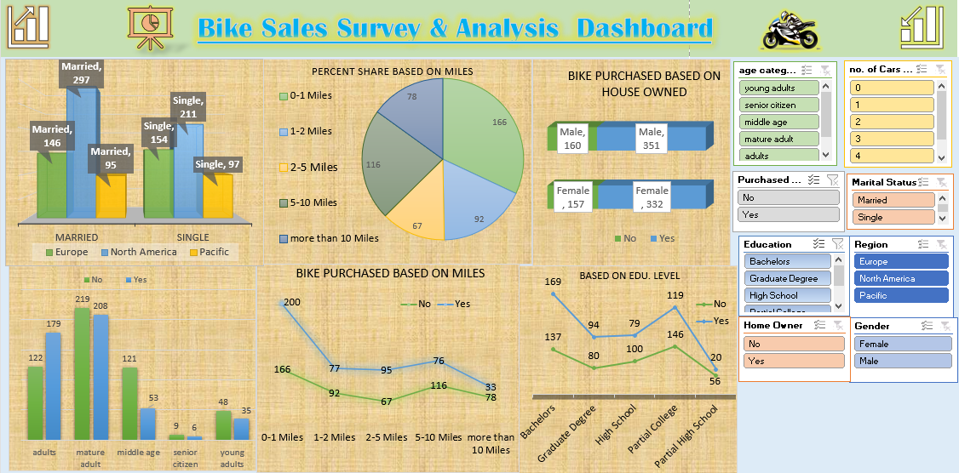
- Age Bracket Demographics: An overview of purchase volumes distributed across different age categories.

Conclusion & Business Insights

The Excel-based dashboard successfully maps out the socioeconomic landscape of potential bike buyers. Key takeaways indicate that middle-aged professionals with shorter commute times and higher average incomes form the core purchasing demographic. These insights can be directly applied to tailor future marketing campaigns, optimize ad spend, and forecast inventory demands based on regional characteristics.

References

- “Bike sales survey raw & uncleaned Dataset.csv”, Project DataSet
- “Bike sales survey cleaned Dataset & Dahboard.xlsx”, for Interactive Dashboard.
- @mdrashidah, "bike sales survey report & dashboard project," MS EXCEL Projects for Data Analysis, GitHub Repository, 2026.

